A
MINI PROJECT On

Heal Mate: Bridging Healthcare and innovation with LLMs and NLP-

Driven Ai
Submitted to
JAWAHARLAL NEHRU TECHNOLOGICAL UNIVERSITY, HYDERABAD
In partial fullfilment of the requirement for the award of the degree of
BACHELOR OF TECHNOLOGY
in
COMPUTER SCIENCE AND ENGINEERING – (AI-ML)
Submitted By (BATCH – B-25)
MUNNELLI SRIJA 227Y1A66B7
MOGILI SAINTH 227Y1A66A2

Under the Guidance of
Ms. D.G.V. Divya, Asst. Professor

DEPARTMENT OF COMPUTER SCIENCE AND ENGINEERING – (AI-ML)
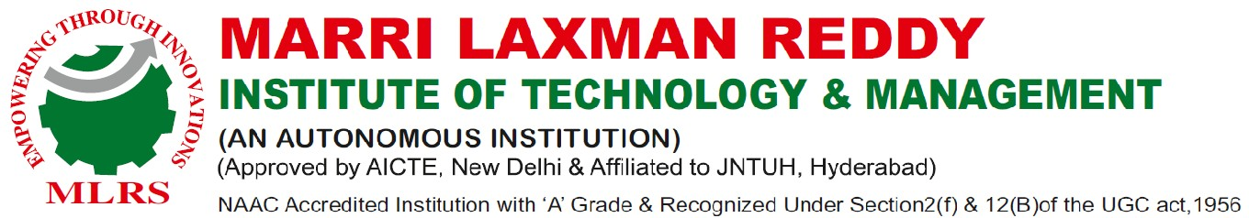
JUNE, 2025



DEPARTMENT OF COMPUTER SCIENCE AND ENGINEERING – (AI-ML)
Date:

CERTIFICATE
This is to certify that the project work entitled “HELPI - A HEALTHCARE CHATBOT” work done by MUNNELLI SRIJA (227Y1A66B7) and MOGILI SAINATH (227Y1A66A2) student(s) of Department of Computer Science and Engineering – Ai and ml, is a record of Bonafide work carried out by the member(s) during a period from January, 2025 to June, 2025 under the supervision of Ms. D.G.V. Divya. This project is done as a fulfilment of obtaining Bachelor of Technology Degree to be awarded by Jawaharlal Nehru Technological University Hyderabad, Hyderabad.
The matter embodied in this project report has not been submitted by us to any other university for the award of any other degree.
MUNNELLI SRIJA MOGILI SAINATH
This is to certify that the above statement made by the candidate(s) is correct to the best of my knowledge.

Date: (Mrs. D.G.V. Divya.)

The Viva-Voce Examination of above student(s), has been held on………………………

Head of the Department External Examiner

Principal/Director

ACKNOWLEDGEMENTS
We would like to express my sincere gratitude to my guide Mrs. D.G.V. Divya, CSM, for her excellent guidance and invaluable support, which helped me accomplish the B. Tech (CSM) degree and prepared me to achieve more life goals in the future. His total support of my dissertation and countless contributions to my technical and professional development made for a truly enjoyable and fruitful experience. Special thanks are dedicated for the discussions we had on almost every working day during my project period and for reviewing my dissertation.
We are very much grateful to my Project Coordinator, Mr. B. Nagendra Reddy Associate Professor, CSM, MLRITM, Dundigal, Hyderabad, who has not only shown utmost patience, but was fertile in suggestions, vigilant in directions of error and has been infinitely helpful.
We are extremely grateful to Dr. B. Ravi Prasad, Professor HOD CSM MLRITM, Dundigal, Hyderabad, for the moral support and encouragement given in completing my project work.
We wish to express deepest gratitude and thanks to Dr. R. Murali Prasad, Principal, and Dr. P. Sridhar, Director for their constant support and encouragement in providing all the facilities in the college to do the project work.
We would also like to thank all our faculties, administrative staff and management of MLRITM, who helped me to completing the A Healthcare Chatbot project.
On a more personal note, I thank my beloved parents and friends for their moral support during the course of our project.

Department of Computer Science and Engineering (AIML)

Vision and Mission
Vision

To nurture globally competent professionals in Artificial Intelligence and Machine Learning through excellence in education, research, and innovation, committed to developing sustainable and impactful solutions for the betterment of society
Mission
To provide a transformative learning environment that equips students with in-depth knowledge and practical skills in Artificial Intelligence and Machine Learning, fostering innovation, leadership, and lifelong learning. To advance AI and ML through cutting-edge research, strong industry collaboration, and community engagement, preparing students to address real-world challenges on a global scale.
To produce competent and ethical AI professionals who contribute to technological progress while addressing societal and environmental challenges with sustainable solutions. To foster a research-driven culture by partnering with industry and academia, encouraging entrepreneurship, and engaging in community-centered technology development.

Program Outcomes

PO1: Engineering knowledge: Applied software engineering, AI, web development, and database management knowledge to build the platform.
PO2: Problem analysis: Identified and analyzed the complex problem of personal finance management, researching needs and formulating an AI-driven solution.
PO3: Design/development of solutions: Designed and developed the full-stack architecture, user interfaces, and secure backend processes to meet financial management needs.
PO4: Conduct investigations of complex problems: Investigated and selected appropriate modern technologies like Google Gemini AI and Supabase, integrating them effectively.
PO5: Modern tool usage: Proficiently used modern tools including Next.js, Supabase, Prisma, Google Gemini AI API, VS Code, and Git for development.
PO6: The engineer and society: Addressed a societal need by aiming to reduce financial stress and enhance financial literacy, considering data privacy and ethical AI use.
PO7: Environment and sustainability: Promoted financial sustainability for users and demonstrated efficient resource use through cloud-native services in development.
PO8: Ethics: Adhered to ethical principles in handling sensitive financial data, ensuring privacy, security, and responsible AI usage.
PO9: Individual and team work: Demonstrated effective individual project management and potential teamwork in a multidisciplinary development environment.
PO10: Communication: Communicated project details, architecture, and features effectively through documentation and potential presentations.
PO11: Project management and finance: Applied engineering and management principles to organize project development, manage resources, and understand financial concepts within the
project's domain.
PO12: Life-long learning: Demonstrated continuous learning by mastering rapidly evolving technologies relevant to fintech and AI

TABLE OF CONTENTS
 |  |  |  | Page No
Chapter 1: Introduction |  |  |  | 1-5
 | 1.1 | Scope of Project |  | 2-3
 | 1.2 | Feasibility Study |  | 4-5
Chapter 2: System Specifications |  |  |  | 14-15
 | 2.1 |  | Hardware Requirements | 15
 |  | 2.1.1 | Processor: Intel i5 or i7 | 15
 |  | 2.1.2 | Memory (RAM): 2GB | 15
 | 2.2 |  | Software Requirements | 15
 |  | 2.2.1 | Operating System: Windows | 15
 |  | 2.2.2 | Programming Language: Python | 15
 |  | 2.2.3 | NLP Libraries: re | 15
 |  | 2.2.4 | Machine Learning libraries: Pandas, sklearn, NumPy, csv | 15
 |  | 2.2.5 | IDE: PyCharm | 15
 |  | 2.2.6 | Front end: Python-Streamlit | 15
Chapter 3: Literature Survey |  |  |  | 16-17
Chapter 4: Software Requirement Analysis |  |  |  | 18-27
 | 4.1 |  | Existing Approaches | 19-20
 | 4.2 |  | Proposed Systems | 20-21
 | 4.3 |  | Modules | 21-27
Chapter 5: Software Design |  |  |  | 28-42
 | 5.1 |  | Introduction | 29
 | 5.2 |  | Software Techniques | 29-30
 | 5.3 |  | Data Flow Diagrams | 30-35
 | 5.4 |  | UML Diagrams | 35-40
 |  | 5.4.1 | Sequence Diagram | 38-39
 |  | 5.4.2 | Use Case Diagram | 39
 |  | 5.4.3 | Activity Diagram | 39-40
 | 5.5 |  | E-R Diagram | 40-42
Chapter 6: Technology Description and Coding |  |  |  | 43-57
 | 6.1 |  | Technology Description | 43-45
 | 6.2 |  | Coding | 45-57
Chapter 7: Testing |  |  |  | 58-61
 | 7.1 |  | Testing | 58
 | 7.2 |  | Testing Type | 58
 |  | 7.2.1 | Unit Testing | 58-59
 |  | 7.2.2 | Integration Testing | 59
 |  | 7.2.3 | Functional Testing | 59
 |  | 7.2.4 | System Testing | 59
 |  | 7.2.5 | Acceptance Testing | 60
 | 7.3 |  | Testcases | 60-61
Chapter 8: Screenshots |  |  |  | 62-63
Chapter 9: Conclusion and Future Scope |  |  |  | 64-65
 | 9.1 | Conclusion
 | 9.2 | Future Scope |  | 66-67
References |  |  |  | 68-69

LIST OF FIGURES
Figure No. |  | Name of the Figure | Page No.
Figure 4.3 | Modules |  | 21
Figure 5.1 | Dataflow diagram |  | 35
Figure 5.4.1 | Sequence diagram |  | 37
Figure 5.4.2 | Use Case Diagram |  | 38
Figure 5.4.3 | Activity Diagram |  | 39
Figure 5.5 | ER diagram |  | 41

ABSTRACT

Due to technological advancements, the healthcare industry has witnessed the emergence of innovative solutions, and one such solution is the healthcare chatbot. The primary objective of this project is to create a healthcare chatbot capable of offering medical assistance to patients. The healthcare chatbot serves as an AI-based conversational program designed to assist both patients and healthcare providers. The proposed chatbot, named "HELPI," functions as a round the-clock healthcare provider. It utilizes natural language processing (NLP) and machine learning (ML) algorithms such as decision trees to analyze user-provided symptoms and accurately detect specific illnesses or diseases. Subsequently, it offers appropriate healthcare recommendations and suggests relevant medications. This broadens HELPI's capability to address various healthcare-related concerns. In essence, HELPI aims to alleviate the burden on healthcare providers by providing an alternative platform for basic medical advice and support. The success of the HELPI chatbot lays the foundation for future enhancements. Additional features, such as appointment scheduling, guidance on lifestyle modifications, and medication reminders, could be incorporated to further enhance the chatbot's functionality.

CHAPTER 1
INTRODUCTION

Introduction
Machine learning is an artificial intelligence technique that enables computers to learn from data and enhance their performance in specific tasks. Machine learning is a dynamic field within artificial intelligence that has revolutionized the way computers process and learn from data. It involves the development of algorithms and models that can automatically improve their performance on specific tasks as they are exposed to more data. This iterative learning process enables machines to make predictions, decisions, and take actions based on patterns and insights derived from large datasets. It encompasses various algorithms, including supervised learning, unsupervised learning, and reinforcement learning. Supervised learning is one of the fundamental approaches in machine learning. It involves training a model using labeled data, where the inputs are paired with corresponding desired outputs or labels. The goal is for the model to learn the underlying patterns in the data and be able to accurately predict the outputs for new, unseen inputs. This technique is widely used in applications such as image recognition, speech recognition, and sentiment analysis. Unsupervised learning, on the other hand, deals with unlabeled data. The goal here is to discover hidden structures, patterns, and relationships within the data without any predefined labels. Clustering and dimensionality reduction are common unsupervised learning techniques. Clustering algorithms group similar data points together based on their inherent properties, while dimensionality reduction techniques aim to reduce the complexity of the data by extracting the most relevant features. Reinforcement learning is a type of machine learning where an agent learns to interact with an environment in order to maximize a reward signal. The agent takes actions, receives feedback in the form of rewards or penalties, and adjusts its behavior accordingly. Through a process of trial and error, the agent learns the optimal policy or strategy to achieve the maximum cumulative reward. Reinforcement learning has been successfully applied in various domains, including game playing (e.g., AlphaGo), robotics, and autonomous vehicles
Building a machine learning system typically involves several steps
- Data preparation Gathering, cleaning, and preparing data for training the model.
- Feature extraction Identifying relevant features crucial for the model to learn from.
- Model selection Choosing the appropriate algorithm that suits the specific problem.
- Training Using the data to train the model to learn from input data and labels.
- Evaluation Testing the model on separate data to assess its performance and adjust parameters if necessary.
- Deployment Integrating the model into the desired application or system. Machine learning finds extensive applications in various fields such as computer vision, natural language processing, healthcare, finance, and more. It offers valuable tools for businesses and organizations aiming to enhance their operations and decision-making processes. Natural Language Processing (NLP) is a subfield of machine learning that focuses on human-computer interaction using natural language. Chatbots utilize NLP techniques to comprehend and interpret human language, enabling appropriate responses. Intent classification is essential for chatbots as it involves identifying the purpose or goal behind a user's message, aiding in understanding and responding accurately. Intent classification can employ machine learning techniques like supervised learning and deep learning. Entity recognition involves identifying specific entities like names, locations, dates, and organizations in a user's message, facilitating personalized and relevant responses. Machine learning techniques like named entity recognition (NER) can be used for entity recognition tasks.

1.1 Scope of Project
Healthcare plays a crucial role in people's lives, but it can be difficult to access in certain situations, such as remote locations, emergencies, or when individuals are unable to physically visit healthcare facilities. To address this challenge, chatbots have emerged as a popular solution, leveraging technology to provide round-the-clock medical assistance. HELPI is an intelligent healthcare chatbot that aims to meet this need by delivering personalized healthcare support to patients.
The HELPI chatbot is designed to handle a broad spectrum of medical inquiries, ranging from minor concerns to serious conditions. Powered by artificial intelligence (AI) and natural language processing (NLP), it efficiently and effectively provides medical assistance to patients. Its user-friendly interface enables patients to interact with the chatbot using natural language, allowing them to easily access the desired healthcare support. Whether through smartphones, laptops, or desktops, HELPI ensures seamless access to healthcare services for patients.
HELPI offers personalized healthcare assistance to patients as one of its key advantages. By harnessing the power of AI and NLP, the chatbot can comprehend and interpret patients' medical inquiries, providing them with accurate and relevant medical advice. Furthermore, HELPI can guide patients on appropriate steps to take based on their symptoms, medical history, and other pertinent factors. This tailored approach empowers patients to make well informed decisions regarding their health and overall well-being.
Another significant benefit of HELPI is its ability to alleviate the burden on healthcare providers. With the rising demand for healthcare services, healthcare providers often struggle to deliver timely medical assistance to patients. By offering a readily accessible 24/7 medical assistant, HELPI lightens the load on healthcare providers, enabling them to prioritize patients in need of immediate medical attention.
Privacy and confidentiality are paramount in HELPI's design. All medical queries and patient data shared within the chatbot remain confidential and secure. Rigorous testing ensures the chatbot's ability to provide accurate and reliable medical assistance to patients.
To provide comprehensive guidance to users, documentation is available to facilitate interaction with HELPI. This documentation outlines the chatbot's features, operations, and troubleshooting steps, aiming to equip users with a thorough understanding of HELPI and maximize their experience with this innovative healthcare chatbot.

Advantages of this chatbot:
- Enhancing Patient Engagement
- Providing 24/7 Support
- Reducing Healthcare Costs
- Improving Health Outcomes • Enhancing Data Collection

1.2 Feasibility Study
Feasibility study is conducted once the problem is clearly understood. Feasibility study is a high-level capsule version of the entire system analysis and design process. The objective is to determine quickly at a minimum expense how to solve a problem. The purpose of feasibility is not to solve the problem but to determine if the problem is worth solving. The feasibility of the project is analyzed in this phase and business proposal is put forth with a very general plan for the project and some cost estimates. During system analysis the feasibility study of the proposed system is to be carried out. This is to ensure that the proposed system is not a burden to the company. For feasibility analysis, some understanding of the major requirements for the system is essential.
Three key considerations involved in the feasibility analysis are
1.ECONOMICAL FEASIBILITY
2.TECHNICAL FEASIBILITY
3. SOCIAL FEASIBILITY
ECONOMICAL FEASIBILITY:
This study is carried out to check the economic impact that the system will have on the organization. The amount of fund that the company can pour into the research and development of the system is limited. The expenditures must be justified. Thus, the developed system as well within the budget and this was achieved because most of the technologies used are freely available. Only the customized products had to be purchased.
TECHNICAL FEASIBILITY
This study is carried out to check the technical feasibility, that is, the technical requirements of the system. Any system developed must not have a high demand on the available technical resources. This will lead to high demands on the available technical resources. This will lead to high demands being placed on the client. The developed system must have a modest requirement, as only minimal or null changes are required for implementing this system.
SOCIAL FEASIBILITY
The aspect of study is to check the level of acceptance of the system by the user. This includes the process of training the user to use the system efficiently. The user must not feel threatened by the system, instead must accept it as a necessity. The level of acceptance by the users solely depends on the methods that are employed to educate the user about the system and to make him familiar with it. His level of confidence must be raised so that he is also able to make some constructive criticism, which is welcomed, as he is the final user of the system.

CHAPTER 2
SYSTEM SPECIFICATIONS

2.1 HARDWARE REQUIREMENTS
- Processor: Intel i5 or i7
- Memory (RAM): 2GB

2.2 SOFTWARE REQUIREMENTS

1. Operating System: Windows 2. Programming languages: Python 3. NLP libraries: re
- Machine learning libraries: Pandas, sklearn, NumPy, csv
- IDE: PyCharm
- Front end: Python-Streamlit

CHAPTER 3
LITERATURE SURVEY

Literature survey is the most important step in software development process. Before developing the tool, it is necessary to determine the time factor, economy and company strength. Once these things are satisfied, then next steps are to determine which operating system and language can be used for developing the tool. Once the programmers start building the tool the programmers need lot of external support. This support can be obtained from senior programmers, from book or from websites. Before building the system, the above consideration is taken into account for developing the proposed system.

CHAPTER 4
SOFTWARE REQUIREMENT ANALYSIS

4.1 EXISTING APPROACHES
The following section summarizes the significant factor regarding the literacy of existing approaches.
- In the publication titled "A Comprehensive Analysis of Chatbot Applications in Mental Healthcare" authored by S. Smith, a thorough examination is conducted on various types of conversational agents employed in the field of healthcare, specifically for chronic conditions. The study investigates the communication technologies, evaluation metrics, and AI methods utilized by these agents. To gather relevant information, a systematic search was conducted in February 2021 across multiple databases including PubMed Medline, EMBASE, PsycINFO, CINAHL, Web of Science, and ACM Digital Library. Among the 26 conversational agents analyzed, 16 were identified as chatbots, seven as embodied conversational agents (ECA), one as a conversational agent within a robot, and another as a relational agent.
- In the article titled "Investigating the Effectiveness of Chatbots in Enhancing Patient Education" authored by J. Brown, there is a growing trend of utilizing chatbots and artificial intelligence in the realm of education and research. The paper delves into the potential applications of AI systems and chatbots in academia and examines their ethical implications on research and education. Employing a qualitative research methodology, the author conducts exploratory research and gathers data through expert analysis and interpretation. The article emphasizes the importance of adapting to the new reality presented by AI systems and chatbots. It highlights the urgency of coexistence, sustainability, and ongoing adaptation to the advancements in these systems. Raising awareness, implementing appropriate legislation, and solidifying ethical values are crucial for fostering research and safeguarding educational systems.
- The study titled "Investigating the Reception and Practicality of Chatbots in Elderly Care Environments" conducted by M. Johnson examines the perceptions of older adults regarding chatbots with different identities for seeking health information.
The research was carried out through a diary and interview study involving 30 participants. The findings indicate 14 that factors such as racial and age similarity impact the level of trust and comfort individuals feel towards chatbots. Additionally, attributes like professionalism, likability, and overall familiarity also influence the reception of chatbots. Based on these insights, the study provides implications for designing text-based chatbots that cater to the needs and preferences of older adults. [4] "Chatbots for Chronic Disease Management: A Review of Current Applications and Challenges" by A. Martinez. This review article aims to report on the recent advances and current trends in chatbot technology in medicine. A brief historical overview, along with the developmental progress and design characteristics, is first introduced. The focus will be on cancer therapy, with in-depth discussions and examples of diagnosis, treatment, monitoring, patient support, workflow efficiency, and health promotion. A search of the literature published in the past 20 years was conducted using the IEEE Xplore, PubMed, Web of Science, Scopus, and OVID databases. The screening of chatbots was guided by the open-access Bot list directory for health care components and further divided according to the following criteria diagnosis, treatment, monitoring, support, workflow, and health promotion.
[5] "Improving Medication Adherence through Chatbot-based Reminders: A Randomized Controlled Trial" by L. Thompson. This study aimed to review the current applications, gaps, and challenges in the literature on conversational agents in health care and provide recommendations for their future research, design, and application. A broad literature search was performed in MEDLINE (Medical Literature Analysis and Retrieval System Online; Ovid), EMBASE (Excerpta Medica database; Ovid), PubMed, Scopus, and Cochrane Central with the search terms
“conversational agents,” “conversational AI,” “chatbots,” and associated synonyms. We also searched the gray literature using sources such as the OCLC (Online Computer Library Center) World Cat database and ResearchGate.

4.2 PROPOSED SYSTEMS
The healthcare industry faces challenges in providing round-the-clock personalized support and advice to patients. Existing resources are often limited, resulting in delays in accessing healthcare services and increased costs. Therefore, there is a need to develop a healthcare chatbot named HELPI that utilizes the decision tree algorithm to engage patients, reduce healthcare costs, improve health outcomes, and enhance data collection.

With the rapid advancement of technology, innovative solutions have emerged in the healthcare industry, including healthcare chatbots. The primary objective of this project is to create a healthcare chatbot capable of providing medical assistance to patients. The healthcare chatbot serves as an AI-powered conversational program designed to assist both patients and healthcare providers. By analyzing patient inquiries and considering symptoms, medical history, and preferences, the chatbot aims to offer tailored responses and provide 24/7 support. Utilizing the decision tree algorithm's interpretability and its ability to handle various types of data, HELPI can deliver personalized advice and support to patients.

The key goal is to achieve a high accuracy rate in providing appropriate responses, ensuring patients receive timely assistance and valuable healthcare information. HELPI is a chatbot that functions as a 24/7 healthcare provider, assisting users in detecting specific illnesses or diseases based on their provided symptoms and offering appropriate healthcare advice and medication recommendations. To deliver relevant responses, HELPI utilizes NLP and ML algorithms, such as the decision tree algorithm. The project is developed using modern technologies like Python. HELPI is trained using diverse datasets, including the Disease Prediction Dataset, which enables the chatbot to provide information on a wide range of healthcare-related issues.

4.3 Modules
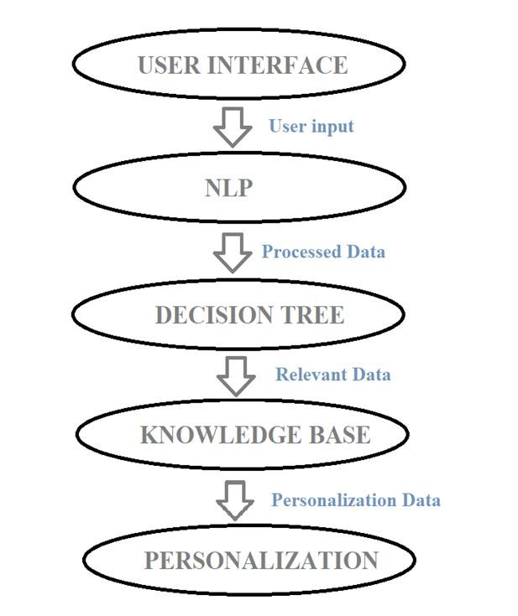
Fig 4.3 Modules
In this diagram:
1.The User Interface module receives user input and sends it to the NLP module. 2. The NLP module processes the user input and passes the processed data to the Decision Tree module.
- The Decision Tree module analyses the data using the CART algorithm and generates appropriate responses.
- The Decision Tree module may also interact with the Knowledge Base module to retrieve relevant healthcare information.
- The Personalization module may utilize the outputs from the Decision Tree module and user specific data to further customize the responses.

1. The User Interface module
The user interface of the HELPI healthcare chatbot is dedicated to creating an interactive and user-friendly platform for users to engage with the chatbot. Its primary focus is on designing and developing an appealing interface that allows users to input their inquiries, view responses, and navigate through the chatbot's features seamlessly.
As a front-end component, the User Interface module plays a critical role in facilitating smooth communication and delivering a user-friendly experience.
Here are some key aspects of the User Interface module
Input Gathering The module enables users to input their inquiries, requests, or symptoms using various methods such as text input fields, voice recognition, or predefined options. It ensures accurate and efficient capture of user input.
User Guidance the User Interface module provides clear instructions and prompts to guide users throughout their interactions with the chatbot. It may offer hints, suggestions, or examples to help users formulate their inquiries effectively. This ensures that users have a clear understanding of how to interact with the chatbot and what information is expected from them. Response Display The module receives responses generated by other modules, such as the Decision Tree or Personalization module, and is responsible for presenting these responses to users in a readable and user-friendly format. By serving as the interface between users and the chatbot system, the User Interface module facilitates intuitive and interactive communication. It prioritizes a user-friendly design, provides guidance during conversations, and presents responses clearly. Ultimately, the module plays a crucial role in ensuring a positive user experience and promoting engagement with the HELPI healthcare chatbot.

2. Natural Language Processing (NLP) Module
The NLP module is responsible for processing and understanding user inquiries and responses. It involves the implementation of algorithms and techniques such as text preprocessing, tokenization, part-of-speech tagging, named entity recognition, and sentiment analysis to extract meaningful information from user input. The NLP module is a critical component of healthcare chatbot system that is responsible for processing and understanding user input. It incorporates various natural language processing techniques to analyze and extract meaningful information from the input.
Here are some key aspects of the NLP module
Text Pre-processing the NLP module performs text pre-processing tasks to clean and normalize the user input. It removes irrelevant characters, punctuation, or special symbols. It may also handle common pre-processing tasks such as lowercase conversion, removing stop words, and handling abbreviations or acronyms.
Tokenization The NLP module breaks down the user input into individual tokens or words. It splits the input into meaningful units, allowing further analysis at the word or phrase level.
Tokenization helps in understanding the structure of the input and identifying key elements for analysis.
Part-of-Speech (POS) Tagging the NLP module performs part-of-speech tagging to assign grammatical tags to each word in the user input. It identifies the role of each word in the sentence, such as nouns, verbs, adjectives, etc. POS tagging helps in understanding the syntactic structure of the input and can aid in extracting relevant information.
Named Entity Recognition (NER) The NLP module incorporates named entity recognition techniques to identify and classify named entities in the user input. It can identify entities such as names of people, organizations, locations, medical terms, or other specific entities relevant to the healthcare domain. NER helps in extracting important entities that may be used for further analysis or to retrieve relevant information from the knowledge base.
Sentiment Analysis the NLP module may perform sentiment analysis to understand the sentiment or emotion expressed in the user input. It analyses the tone or polarity of the text, classifying it as positive, negative, or neutral. Sentiment analysis can provide insights into the user's emotional state or sentiment, which can be considered in generating appropriate responses.
Intent Recognition the NLP module identifies the user's intent or purpose behind the input. It aims to understand the user's goal or desired outcome from the conversation. Intent recognition helps in directing the conversation flow and determining the appropriate response strategy.
Contextual Understanding the NLP module considers the context of the conversation to enhance understanding and generate context-aware responses. It maintains the dialogue history and takes into account previous interactions to provide more relevant and coherent responses. Contextual understanding allows the chatbot to maintain a natural and continuous conversation with the user.
The NLP module plays a crucial role in deciphering user input, extracting meaningful information, and transforming it into a structured format that can be further processed by other modules. It incorporates various techniques to understand the syntax, semantics, and context of the input, enabling the chatbot to provide accurate and contextually relevant responses to user inquiries in the healthcare domain.

3. Decision Tree Module
The decision tree module forms the core of the healthcare chatbot's decision-making process. It includes the implementation of the decision tree algorithm, specifically the CART algorithm, to analyze patient inquiries and generate appropriate responses. These 29 modules involve constructing the decision tree, training it using relevant data, and configuring hyperparameters to optimize its performance.
The Decision Tree module forms the core of chatbot's decision-making process. It utilizes the CART (Classification and Regression Trees) algorithm, which is a decision tree-based machine learning algorithm, to analyze the processed data from the NLP module and make informed decisions. Here are some key aspects of the Decision Tree module.
Feature Selection the Decision Tree module takes the processed data from the NLP module, which typically includes various features extracted from the user input. It selects the most relevant features to consider for decision-making. The selection of features can be based on their importance, relevance to the healthcare domain, or their ability to contribute to accurate decision-making.
Tree Construction the Decision Tree module constructs a decision tree based on the selected features and the corresponding target variable. It utilizes the CART algorithm, which recursively partitions the data based on different feature values, creating nodes and branches in the decision tree. The tree construction process involves determining the optimal splitting criteria for each node, such as Gini impurity or information gain, to maximize the predictive power of the tree.
Decision Making the Decision Tree module uses the constructed decision tree to make decisions based on the features of the user input. It follows the paths in the tree based on the values of different features, leading to a specific decision or action. The decision-making process involves evaluating the feature values at each node and traversing the tree until reaching a leaf node that represents a specific decision or recommendation.
Classification and Prediction the Decision Tree module can perform both classification and prediction tasks. In classification, it assigns a predefined label or category to the user input based on the decision tree's paths. In prediction, it estimates a numerical value or outcome based on the feature values and their corresponding decision tree paths.
Model Evaluation and Optimization the Decision Tree module can be evaluated and optimized to improve its performance and accuracy. Evaluation techniques, such as cross validation or performance metrics like accuracy, precision, recall, or F1 score, can be used to assess the effectiveness of the decision tree model. Optimization techniques, such as pruning or tuning hyperparameters, can be applied to enhance the decision tree's generalization ability and avoid overfitting.
Explainability The Decision Tree module provides explainability for the decisions made by the chatbot. As decision trees are interpretable models, the module can trace the decision-making process back to the specific feature values and paths in the tree. This transparency allows users to understand how the chatbot arrived at a particular decision or recommendation, enhancing trust and confidence in the chatbot's responses.
The Decision Tree module leverages the CART algorithm to analyze the processed data, construct a decision tree, and make decisions based on the features of the user input. It offers flexibility, interpretability, and the ability to handle both classification and prediction tasks. By employing model evaluation and optimization techniques, the Decision Tree module ensures accurate decision-making and enhances the overall performance of healthcare chatbot

4. Knowledge Base Module
The knowledge base module acts as a repository of healthcare-related information, enabling the chatbot to provide accurate and up-to-date responses. It involves the collection and organization of medical knowledge, including symptoms, diseases, treatments, medications, and other relevant healthcare information.
The Knowledge Base module serves as a repository of healthcare-related information. It stores a wide range of medical knowledge, including symptoms, diseases, treatments, medications, and other relevant healthcare data. Here are some key aspects of the Knowledge Base module
Information Storage the Knowledge Base module stores structured and organized information related to the healthcare domain. It can utilize databases, knowledge graphs, or other data storage mechanisms to efficiently store and retrieve information. Data Curation The module may incorporate data validation and quality control processes to ensure the accuracy and integrity of the information.
Information Retrieval the Knowledge Base module provides mechanisms to retrieve relevant information based on user inquiries or queries. It uses search algorithms or query processing techniques to identify and retrieve the most relevant information from the knowledge base. The module considers factors such as keyword matching, semantic similarity, or relevance ranking to retrieve accurate and contextually appropriate information.
Contextual Integration the Knowledge Base module integrates the retrieved information with the ongoing conversation or user context. It ensures that the retrieved information is relevant and tailored to the user's specific inquiry or situation.

5. Personalization Module
The personalization module aims to tailor the chatbot's responses to individual users based on their specific needs and preferences. It involves capturing and analyzing user data, such as medical history, demographics, and previous interactions, to customize the chatbot's recommendations and advice.
The Personalization module focuses on tailoring the chatbot's responses to individual users. It aims to provide a personalized and customized experience based on userspecific data and preferences. Here are some key aspects of the Personalization module.
User Profiling It collects and analyses user-specific data to understand the user's characteristics and needs. The module may employ techniques such as machine learning, collaborative filtering, or clustering to derive insights from the user data.
User Contextualization the Personalization module incorporates user context into the conversation flow. The module uses the gathered user data to adapt the chatbot's behavior, recommendations, or suggestions to align with the user's preferences and needs. Recommendation Engine the Personalization module may include a recommendation engine to suggest relevant healthcare information, resources, or actions to the user. The Knowledge Base and Personalization modules work together to ensure that the chatbot provides accurate and personalized healthcare information to users. While the Knowledge Base module acts as a reliable source of medical knowledge.

6. Integration and Deployment Module
The integration and deployment module focuses on integrating the different modules of the healthcare chatbot and deploying it to a production environment. It involves the seamless integration of the user interface, NLP, decision tree, knowledge base, and personalization modules to create a cohesive and functional chatbot. The module may also involve deploying the chatbot on a suitable platform or web server to make it accessible to users.
Each module plays a crucial role in the overall functionality of the healthcare chatbot. By combining these modules effectively, the HELPI chatbot can provide personalized support, accurate responses, and valuable healthcare information to users. The architecture of the HELPI healthcare chatbot emphasizes efficient communication between the client-side user interface and the server-side components. The server-side infrastructure includes NLP processing, decision-making, knowledge base, and personalization, enabling accurate, personalized, and context-aware responses to user inquiries.
The architecture diagram provides an overview of how the different components interact to enable the healthcare chatbot to understand user inquiries, make informed decisions using the decision tree algorithm, and deliver personalized healthcare recommendations. It forms the foundation for the development and implementation of the HELPI chatbot system.

CHAPTER 5
SOFTWARE DESIGN

5.1 INTRODUCTION
This section would analyze the system based on the requirement gathered in the previous section. Analysis would concentrate on what the system should have and should do rather than how it is going to be done. Basically, there are two areas of analysis: data analysis and data flow analysis.

5.2 SOFTWARE TECHNIQUES

OBJECT ORIENTED ANALYSIS AND DESIGN
Object-oriented analysis and design (OAD) are often part of the development of largescale systems and programs often using the Unified Modeling Language (UML). OAD applies object-modeling techniques to analyze the requirements for a context — for example, a system, a set of system modules, an organization, or a business unit — and to design a solution. Most modern object-oriented analysis and design methodologies are using case driven across requirements, design, implementation, testing, and deployment. Use cases were invented with object-oriented programming, but they're also very well suited for systems that will be implemented in the procedural paradigm. The Unified Modeling Language (UML) has become the standard modeling language used in object-oriented analysis and design to graphically illustrate system concepts. Part of the reason for OAD is its use in developing programs that will have an extended lifetime.
Object Oriented Systems
An object-oriented system is composed of objects. The behavior of the system is achieved through collaboration between these objects, and the state of the system is the combined state of al the objects in it. Collaboration between objects involves them sending messages to each other. The exact semantics of message sending between objects varies depending on what kind of system is being modeled. In some systems, "sending a message" is the same as "invoking a method". In other systems, "sending a message" might involve sending data via a socket.
Object Oriented Analysis
Object-Oriented Analysis (OOA) aims to model, the problem we want to solve by developing an object-oriented (OO) system. The source of the analysis is a written requirement statements, and/or written use cases, UML diagrams can be used to illustrate the statements. An analysis model will not take into account implementation constraints, such as concurrency, distribution, persistence, or inheritance, nor how the system will be built. The model of a system can be divided into multiple domains each of which are separately analyzed, and represent separate business, technological, or conceptual areas of interest. The result of object-oriented analysis is a description of what is to be built, using concepts and relationships between concepts, often expressed as a conceptual model. Any other documentation that is needed to describe what is to be built, is also included in the result of the analysis. That can include a detailed user interface mock-up document. The implementation constraints are decided during the object-oriented design (OOD) process.
Object Oriented Design
Object-Oriented Design (OOD) is an activity where the designers are looking for logical solutions to solve a problem, using objects. Object-oriented design takes the conceptual model that is the result of object-oriented analysis, and adds implementation constraints imposed by the environment, the programming language and the chosen tools, as well as architectural assumptions chosen as basis of design.
- As one of the primary sources of the Unified Modeling Language (UML), concepts and notation from OOSE have been incorporated into UML.
- The methodology part of OOSE has since evolved into the Rational Unified Process (RUP).
- The OOSE tools have been replaced by tools supporting UML and RUP.
OOSE has been largely replaced by the UML notation and by the RUP methodology.

5.3 Data Flow Diagrams
A data flow diagram is graphical tool used to describe and analyze movement of data through a system. These are the central tool and the basis from which the other components are developed. The transformation of data from input to output, through processed, may be described logically and independently of physical components associated with the system. These are known as the logical data flow diagrams. The physical data flow diagrams show the actual implements and movement of data between people, departments and workstations. A full description of a system actually consists of a set of data flow diagrams.
DFD SYMBOLS:
In the DFD, there are four symbols
- A square defines a source(originator) or destination of system data.
- An arrow identifies data flow. It is the pipeline through which the information flows.
- A circle or a bubble represents a process that transforms incoming data flow into outgoing data flows.
- An open rectangle is a data store, data at rest or a temporary repository of data.

Process that transforms data flow

Source or Destination of data Data flow

Data Store
CONSTRUCTING A DATA FLOW DIAGRAM:
Several rules of thumb are used in drawing DFD’S:
- Process should be named and numbered for an easy reference. Each name should be representative of the process.
- The direction of flow is from top to bottom and from left to right. Data traditionally flow from source to the destination although they may flow back to the source. One way to indicate this is to draw long flow line back to a source. An alternative way is to repeat the source symbol as a destination. Since it is used more than once in the DFD it is marked with a short diagonal.
- When a process is exploded into lower-level details, they are numbered.
- The names of data stores and destinations are written in capital letters. Process and dataflow names have the first letter of each work capitalized. A DFD typically shows the minimum contents of data store. Each data store should contain all the data elements that flow in and out.
A DFD typically shows the minimum contents of data store. Each data store should contain all the data elements that flow in and out.
Questionnaires should contain all the data elements that flow in and out. Missing interfaces redundancies and like is then accounted for often through interviews.

SAILENT FEATURES OF DFD’S
- The DFD shows flow of data, not of control loops and decision are controlled considerations do not appear on a DFD.
- The DFD does not indicate the time factor involved in any process whether the dataflow take place daily, weekly, monthly or yearly.
- The sequence of event is not brought out on the DFD.

TYPES OF DATA FLOW DIAGRAMS
- Current Physical
- Current Logical
- New Logical
- New Physical
CURRENT PHYSICAL
In Current Physical DFD process label include the name of people or their positions or the names of computer systems that might provide some of the overall systemprocessing label includes an identification of the technology used to process the data. Similarly, data flows and data stores are often labels with the names of the actual physical media on which data are stored such as file folders, computer files, business forms or computer tapes.
CURRENT LOGICAL
The physical aspects at the system are removed as much as possible so that the current system is reduced to its essence to the data and the processors that transforms them regardless of actual physical form.
NEW LOGICAL
This is exactly like a current logical model if the user were completely happy with the user were completely happy with the functionality of the current system but had problems with how it was implemented typically through the new logical model will differ from current logical model while having additional functions, absolute function removal and inefficient flows recognized.
NEW PHYSICAL
The new physical represents only the physical implementation of the new system.
RULES GOVERNING THE DFD’S

PROCESS
- No process can have only outputs.
- No process can have only inputs. If an object has only inputs than it must be a sink.
- A process has a verb phrase label.

DATA STORE
- Data cannot move directly from one data store to another data store, a process must move data.
- Data cannot move directly from an outside source to a data store, a process, which receives, must move data from the source and place the data into data store
- A data store has a noun phrase label.

SOURCE OR SINK
The origin and /or destination of data:
- Data cannot move direly from a source to sink it must be moved by a process.
- A source and /or sink has a noun phrase land.

DATA FLOW
- A Data Flow has only one direction of flow between symbols. It may flow in both directions between a process and a data store to show a read before an update. The latter is usually indicated however by two separate arrows since these happen at different type.
- A join in DFD means that exactly the same data comes from any of two or more different processes data store or sink to a common location.
- A data flow cannot go directly back to the same process it leads. There must be at least one other process that handles the data flow produce some other data flow returns the original data into the beginning process.
- A Data flow to a datastore means update (delete or change).
- A data Flow from a datastore means retrieve or use.
A data flow has a noun phrase label more than one data flow noun phrase can appear on a single arrow as long as al of the flows on the same arrow move together as one package
Data Flow Diagram:
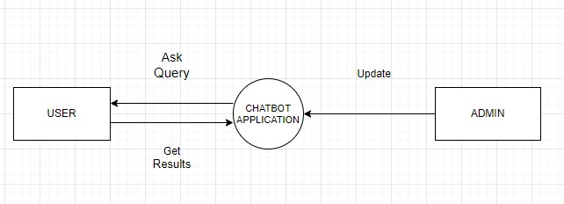
Fig 5.1 Dataflow diagram

5.4 UML Diagrams
UNIFIED MODELING LANGUAGE DIAGRAMS
The unified modeling language allows the software engineer to express an analysis model using the modeling notation that is governed by a set of syntactic semantic and pragmatic rules. A UML system is represented using five different views that describe the system from distinctly different perspective. Each view is defined by a set of diagrams, which is as follows:
• User Model View
1. This view represents the system from the user’s perspective.
2.The analysis representation describes a usage scenario from the end-user’s perspective.
• Structural model view
1. In this model the data and functionality are arrived from inside the system.
2.This model view models the static structures.
- Behavioral Model View
It represents the dynamic of behavioral as parts of the system, depicting the interactions of collection between various structural elements described in the user model and structural model view.
- Implementation Model View
In this the structural and behavioral as parts of the system are represented as they are to be built.
- Environmental Model View
In these the structural and behavioral aspects of the environment in which the system is to be implemented are represented.
UML is specifically constructed through two different domains they are:
1.UML Analysis modeling, this focuses on the user model and structural model views of the system.
2.UML design modeling, which focuses on the behavioral modeling, implementation modeling and environmental model views.
Use case Diagrams represent the functionality of the system from a user’s point of view. Use cases are used during requirements elicitation and analysis to represent the functionality of the system. Use cases focus on the behavior of the system from external point of view. Actors are external entities that interact with the system.
Examples of actors include users like administrator, bank customer …etc., or another system like central database.

UNIFIED MODELING LANGUAGE
The Unified Modeling Language (UML) is a standard language for writing software blueprints. The UML may be used to visualize, specify, construct, and document the artifacts of a software-intensive system. The UML is appropriate for modeling systems ranging from enterprise information systems to distributed Web-based applications and even to hard real time embedded systems. It is a very expressive language, addressing all the views needed to develop and then deploy such systems. The UML is only a language and so is just one part of a software development method. The UML is process independent, although optimally it should be used in a process that is use case driven, architecture-centric, iterative, and incremental.
The UMLis a language for
- Visualizing.
- Specifying.
- Constructing.
- Documenting.
The artifacts of a software-intensive system. A modeling language is a language whose vocabulary and rules focus on the conceptual and physical representation of a system. Modeling yields an understanding of a system. The vocabulary of the UML encompasses three kinds of building blocks:
- Things
- Relationships
- Diagrams

5.4.1 Sequence diagram

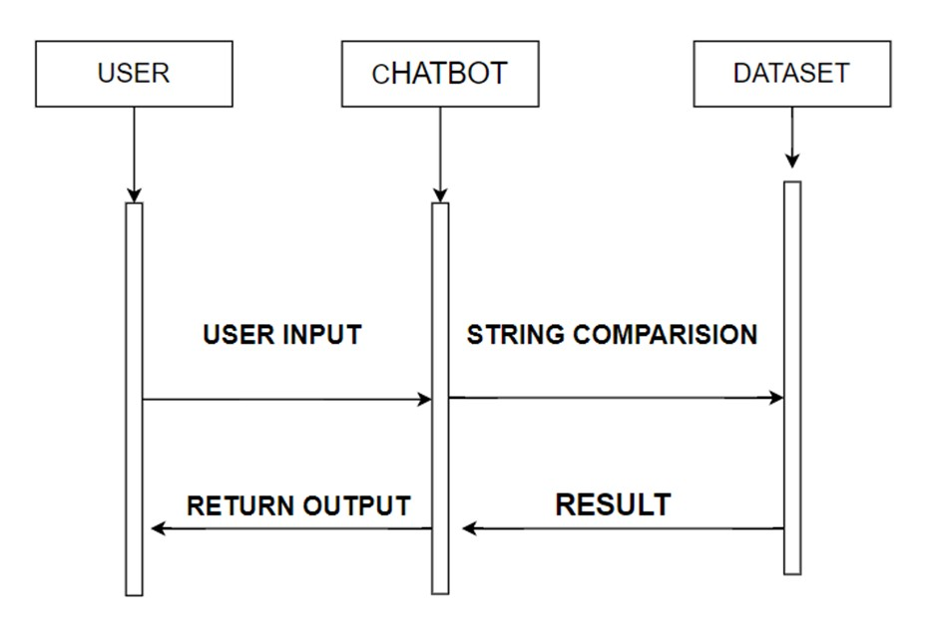 Fig 5.4.1 Sequence diagram
The sequence diagram starts with the user interacting with the chatbot by entering symptoms. The user input is received by the Chatbot. The chatbot then compares the input string entered by the user as input with the dataset.
After string comparison, the chatbot will predict the disease.
After predicting the disease, the chatbot returns the measures to be taken by the user.
Finally, the chatbot displays the results to the user, completing the interaction.

5.4.2 Use Case Diagram

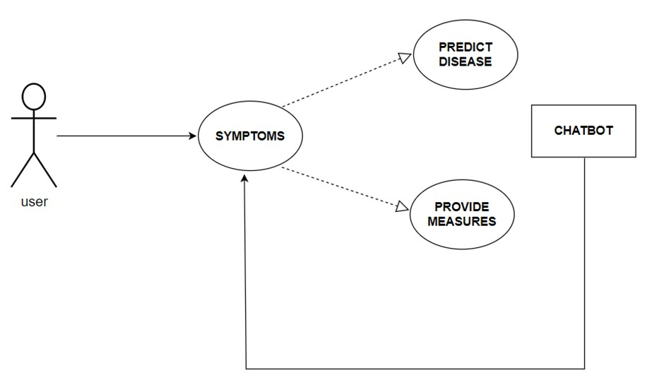

Fig 5.4.2 Use Case Diagram

The use case diagram represents the main actions or functionalities that the healthcare chatbot provides to the user. The central box represents the three use cases associated with the chatbot.
Symptoms This use case represents the user entering symptoms into the chatbot for disease prediction. Predict Disease This use case represents the chatbot processing the symptoms and predicting the likely disease.
Provide Measures This use case represents the chatbot providing recommended measures or actions to be taken based on the predicted disease. Each use case is connected to the chatbot box with a line.

5.4.3 Activity Diagram
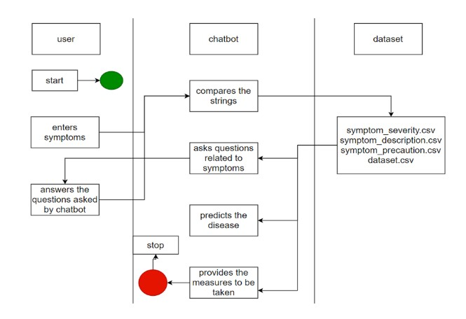
Fig 5.4.3 Activity Diagram
An activity diagram represents the flow of activities or actions within a system The diagram starts with the Start node and proceeds to the Enter Symptoms activity. In the Enter Symptoms activity, the user provides the symptoms to the chatbot. Once the symptoms are entered, the chatbot compares the input string with the dataset and it asks few questions to the user based on the symptoms entered by the user.
Now the chatbot moves to the Predict Disease activity, where it processes the symptoms and predicts the disease.
From the Predict Disease activity, the chatbot proceeds to the Provide Measures activity, where it determines the recommended measures based on the predicted disease.
After providing the measures, the chatbot moves to the Display Results activity to show the results to the user.
Finally, the flow ends at the Finish node.

5.5 E-R Diagram:
An entity-relationship (ER) diagram is a specialized graphic that illustrates the interrelationships between entities in a database. An entity-relationship model (ERM) in software engineering is an abstract and conceptual representation of data. Entityrelationship modeling is a relational schema database modeling method, used to produce a type of conceptual schema or semantic data model of a system, of a relational database. After carefully understanding the requirements of the client the entire data storage requirements are divided into tables. The below tables are normalized to avoid any anomalies during the course of data entry.

Normalization
It is a process of converting a relation to a standard form. The process is used to handle the problems that can arise due to data redundancy i.e. repetition of data in the database, maintain data integrity as well as handling problems that can arise due to insertion, updating, deletion anomalies.
Decomposing is the process of splitting relations into multiple relations to eliminate anomalies and maintain anomalies and maintain data integrity. To do this we use normal forms or rules for structuring relation.
Insertion anomaly: Inability to add data to the database due to absence of other data.
Deletion anomaly: Unintended loss of data due to deletion of other data.
Update anomaly: Data inconsistency resulting from data redundancy and partial update

Normal Forms: These are the rules for structuring relations that eliminate anomalies.
FIRST NORMAL FORM:
A relation is said to be in first normal form if the values in the relation are atomic for every attribute in the relation. By this we mean simply that no attribute value can be a set of values or, as it is sometimes expressed, a repeating group.
SECOND NORMAL FORM:
A relation is said to be in second Normal form is it is in first normal form and it should satisfy any one of the following rules. 1) Primary key is a not a composite primary key
- No non key attributes are present
- Every non key attribute is fully functionally dependent on full set of primary Key.
THIRD NORMAL FORM:
A relation is said to be in third normal form if their exits no transitive dependencies.

Transitive Dependency: If two non-key attributes depend on each other as well as on the primary key then they are said to be transitively dependent. The above normalization principles were applied to decompose the data in multiple tables thereby making the data to be maintained in a consistent state.

ER Diagram:
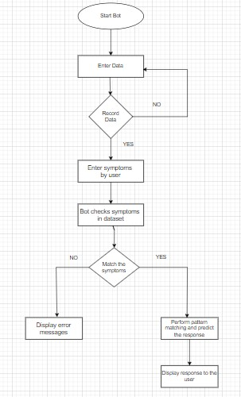
Fig 5.5 ER diagram

CHAPTER 6
TECHNOLOGY DESCRIPTION AND CODING

6.1 TECHNOLOGY DESCRIPTION
Natural Language Processing:
Natural Language Processing (NLP) is a field of artificial intelligence that focuses on the interaction between computers and human languages. It involves the development of algorithms and models that enable computers to understand, interpret, and generate human language. The goal of NLP is to bridge the gap between human communication and computer understanding, allowing for applications such as language translation, sentiment analysis, chatbots, and more. Key techniques in NLP include tokenization, parsing, semantic analysis, machine translation, and speech recognition.

Challenges in NLP
- Ambiguity and Context Understanding:
  - Natural language is often ambiguous and context-dependent, making it challenging for models to accurately interpret meaning.
- Sarcasm and Irony:
  - Detecting sarcasm and irony requires deep contextual understanding and is difficult for models to grasp.
- Language Diversity:
  - Dealing with different languages, dialects, and vernaculars, each with unique syntax, semantics, and idiomatic expressions.
- Domain-Specific Knowledge:
  - Tailoring NLP models to understand and process text from specific domains (e.g., legal, medical) can be complex and data-intensive.
- Resource-Intensive Training:
  - Training state-of-the-art NLP models requires substantial o computational resources and large datasets.

Machine learning:
Machine Learning (ML) is a subset of artificial intelligence (AI) that enables systems to learn and improve from experience without being explicitly programmed. It involves the development of algorithms that can identify patterns in data, make decisions, and predict outcomes based on input data. Machine learning is widely used in various applications, such as image and speech recognition, recommendation systems, and autonomous vehicles.
Types of Machine Learning
1. Supervised Learning 2. Unsupervised Learning 3. Semi-Supervised Learning 4. Reinforcement Learning

Decision Tree Algorithm Selection and Configuration (CART Algorithm)
Choosing and configuring the decision tree algorithm is a critical aspect of developing the HELPI healthcare chatbot. The CART algorithm, which is capable of handling both classification and regression tasks, has been selected for this project. It partitions the data recursively based on chosen features to create subsets that are as pure as possible in relation to the target variable. The resulting decision tree consists of internal nodes representing feature tests and leaf nodes representing predicted responses.
The decision to use the CART algorithm is driven by its flexibility in dealing with mixed data types, encompassing categorical and numerical variables. This adaptability is particularly advantageous in the healthcare field where patient inquiries often involve a combination of symptoms, medical history, and preferences, necessitating a versatile algorithm for effective decision-making. Configuring the CART algorithm involves adjusting essential hyperparameters to optimize its performance. Key considerations include the maximum depth of the tree, the minimum number of samples required for node splitting, and the minimum number of samples needed at a leaf node. The maximum depth governs the tree's complexity, with deeper trees capturing more intricate relationships but also risking overfitting. It is crucial to experiment with different depth values and evaluate the model's performance to strike the right balance between complexity and generalization.
Optimal configuration of the CART algorithm is typically achieved through experimentation and evaluation using performance metrics like accuracy, precision, recall, or F1 score. Techniques such as cross-validation can be employed to assess performance on different subsets of data and mitigate issues of overfitting or underfitting. Additionally, post-pruning techniques can be applied to trim the fully grown decision tree, reducing complexity by removing unnecessary branches or nodes. Pruning enhances generalization and prevents overfitting. Common methods include cost complexity pruning (alpha pruning) and reduced error pruning.
Database: A database management system (DBMS) is computer software designed for the purpose of managing databases, a large set of structured data, and run operations on the data requested by numerous users. Typical examples of DBMSs include Oracle, DB2, Microsoft Access, Microsoft SQL Server, Firebird, PostgreSQL, Oracle, SQLite, FileMaker and Sybase Adaptive Server Enterprise. DBMSs are typically used by Database administrators in the creation of Database systems. Typical examples of DBMS use include accounting, human resources and customer support systems. Originally found only in large companies with the computer hardware needed to support large data sets, DBMSs have more recently emerged as a fairly standard part of any company back office.

6.2 Coding
Sample code:
import numpy as np import pandas as pd import csv import re from sklearn import preprocessing import seaborn as sns import matplotlib.pyplot as plt

from sklearn. model_ selection import train_test_split

from sklearn.tree import DecisionTreeClassifier, _tree

from sklearn.model_selection import cross_val_score

from sklearn.svm import SVC

import warnings warnings.filterwarnings("ignore", category=DeprecationWarning)
!sudo apt-get install espeak !pip install pyttsx3 import pyttsx3 engine = pyttsx3.init() def text_to_speech(text):
engine.setProperty('rate', 150) # Speed percent (can go over 100) engine.setProperty('volume', 0.9) # Volume 0-1

engine.say(text) engine.runAndWait() training = pd.read_csv('/content/Data/Training.csv') testing= pd.read_csv('/content/Data/Testing.csv') shape = training.shape print("Shape of Training dataset: ", shape) description = training.describe() description info_df = training.info() info_df null_values_count = training.isnull().sum() null_values_count training.head(8) cols= training.columns cols= cols[:-1]

- = training[cols] y = training['prognosis'] plt.figure(figsize=(10, 20)) sns.countplot(y='prognosis', data=training) plt.title('Distribution of Target (Prognosis)') plt.show()
reduced_data = training.groupby(training['prognosis']).max()

reduced_data.head() le = preprocessing.LabelEncoder()

le.fit(y)
- = le.transform(y)

x_train, x_test, y_train, y_test = train_test_split(x, y, test_size=0.33, random_state=42)

testx = testing[cols]

testy = testing['prognosis']

testy = le.transform(testy) clf1 = DecisionTreeClassifier() clf = clf1.fit(x_train,y_train)

scores = cross_val_score(clf, x_test, y_test, cv=3)

print("Mean Score: ",scores.mean()) model=SVC()

model.fit(x_train,y_train)

print("Accuracy score for svm: ", model.score(x_test,y_test))

importances = clf.feature_importances_

indices = np.argsort(importances)[::-1]

features = cols

severityDictionary=dict() description_list = dict() precautionDictionary=dict()

symptoms_dict = {}

for index, symptom in enumerate(x): symptoms_dict[symptom] = index

def calc_condition(exp,days):
sum=0 for item in exp:
sum=sum+severityDictionary[item]
if((sum*days)/(len(exp)+1)>13):
print("You should take the consultation from doctor. ") else:
print("It might not be that bad but you should take precautions.")

def getDescription(): global description_list with open('/content/Data/symptom_Description.csv') as csv_file:
csv_reader = csv.reader(csv_file, delimiter=',') line_count = 0 for row in csv_reader: _description={row[0]:row[1]} description_list.update(_description)

def getSeverityDict():
global severityDictionary with open('/content/Data/Symptom_severity.csv') as csv_file:

csv_reader = csv.reader(csv_file, delimiter=',') line_count = 0 try: for row in csv_reader:
_diction={row[0]:int(row[1])} severityDictionary.update(_diction) except: pass

def getprecautionDict():
global precautionDictionary with open('/content/Data/symptom_precaution.csv') as csv_file:

csv_reader = csv.reader(csv_file, delimiter=',') line_count = 0 for row in csv_reader:
_prec={row[0]:[row[1],row[2],row[3],row[4]]} precautionDictionary.update(_prec)

def getInfo():
print("-----------------------------------HealthCare ChatBot-----------------------------------") print("\nYour Name? \t\t\t\t",end="->") name=input("") print("Hello", name)

def check_pattern(dis_list,inp):
pred_list=[] inp=inp.replace(' ','_') patt = f"{inp}" regexp = re.compile(patt) pred_list=[item for item in dis_list if regexp.search(item)] if(len(pred_list)>0): return 1,pred_list else:
return 0,[]

def sec_predict(symptoms_exp):
df = pd.read_csv('Data/Training.csv') X = df.iloc[:, :-1] y = df['prognosis']
X_train, X_test, y_train, y_test = train_test_split(X, y, test_size=0.3, random_state=20) rf_clf = DecisionTreeClassifier() rf_clf.fit(X_train, y_train)

symptoms_dict = {symptom: index for index, symptom in enumerate(X)} input_vector = np.zeros(len(symptoms_dict)) for item in symptoms_exp:
input_vector[[symptoms_dict[item]]] = 1

return rf_clf.predict([input_vector]) def print_disease(node): node = node[0] val = node.nonzero() disease = le.inverse_transform(val[0]) return list(map(lambda x:x.strip(),list(disease))) engine = pyttsx3.init()

def tree_to_code(tree, feature_names):
tree_ = tree.tree_ feature_name = [ feature_names[i] if i != _tree.TREE_UNDEFINED else "undefined!" for i in tree_.feature
]

chk_dis=",".join(feature_names).split(",") symptoms_present = []

while True:

engine.say("\n Enter the symptom you are experiencing \t\t\t",) engine.runAndWait() print("\nEnter the symptom you are experiencing \t\t",end="->") disease_input = input("")

conf,cnf_dis=check_pattern(chk_dis,disease_input) if conf==1:
print("searches related to input: ") for num, it in enumerate(cnf_dis):
print(num,")",it) if num!=0:
print(f"Select the one you meant (0 - {num}): ", end="") conf_inp = int(input("")) else:
conf_inp=0

disease_input=cnf_dis[conf_inp] break else:
print("Enter valid symptom.")

while True: try:
num_days=int(input("Okay. From how many days ? : ")) break except:
print("Enter valid input.") def recurse(node, depth): indent = " " * depth if tree_.feature[node] != _tree.TREE_UNDEFINED:
name = feature_name[node] threshold = tree_.threshold[node] if name == disease_input: val = 1 else:
val = 0 if val <= threshold:
recurse(tree_.children_left[node], depth + 1) else:
symptoms_present.append(name) recurse(tree_.children_right[node], depth + 1) else:
present_disease = print_disease(tree_.value[node])

red_cols = reduced_data.columns symptoms_given = red_cols[reduced_data.loc[present_disease].values[0].nonzero()]

engine.say("Are you experiencing any") engine.runAndWait() print("Are you experiencing any ") symptoms_exp=[] for syms in list(symptoms_given): inp="" engine.say(f"{syms}, are you experiencing it?") engine.runAndWait() print(syms,"? : ",end='') while True:
inp=input("") if(inp=="yes" or inp=="no"): break else:
print("provide proper answers i.e. (yes/no) : ",end="") if(inp=="yes"):
symptoms_exp.append(syms)

second_prediction=sec_predict(symptoms_exp)
# print(second_prediction) calc_condition(symptoms_exp,num_days) if(present_disease[0]==second_prediction[0]):
engine.say("You may have ", present_disease[0]) engine.runAndWait() print("You may have ", present_disease[0]) print(description_list[present_disease[0]] else:
engine.say(f"You may have {present_disease[0]} or {second_prediction[0]}.") engine.runAndWait() print("You may have ", present_disease[0], "or ", second_prediction[0]) print(description_list[present_disease[0]]) print(description_list[second_prediction[0]]) # print(description_list[present_disease[0]]) precution_list=precautionDictionary[present_disease[0]] print("Take following measures : ") for i,j in enumerate(precution_list):
print(i+1,")",j) recurse(0, 1) getSeverityDict() getDescription() getprecautionDict() getInfo() tree_to_code(clf,cols) print("---------------------------------------------------------------------------------------------------------------------------------")

CHAPTER 7
TESTING

7.1 TESTING
The testing phase is an important part of software development. It is the process of finding errors and missing operations and also a complete verification to determine whether the objectives are met and then user requirements are satisfied.

7.2 TESTING TYPE

7.2.1 Unit Testing
The first includes unit testing, where in each module is tested to provide its correctness, validity and also determine any missing operations and to verify whether the objectives have been met. Errors are noted down and corrected immediately. Unit testing is the important and major part of the project. So, errors are rectified easily in particular module and program clarity is increased. In this project entire system is divided into several modules and is developed individually. So, unit testing is conducted to individual modules.

7.2.2 Integration Testing
The second step includes Integration testing. It need not be the case, the software whose modules when run individually and showing perfect results, will also show perfect results when run as a whole. The individual modules are clipped under this major module and tested again and verified the results. This is due to poor interfacing, which may result in data being lost across an interface. A module can have inadvertent, adverse effect on any other or on the global data structures, causing serious problems. 7.2.3 Functional Testing
Functional tests provide systematic demonstrations that functions tested are available as specified by the business and technical requirements, system documentation, and user manuals.

Functional testing is centered on the following items:
Valid Input: identified classes of valid input must be accepted.
Invalid Input: identified classes of invalid input must be rejected.
Functions: identified functions must be exercised.
Output: identified classes of application outputs must be exercised.
Systems/Procedures: interfacing systems or procedures must be invoked.
Organization and preparation of functional tests is focused on requirements, key functions, or special test cases. In addition, systematic coverage pertaining to identify Business process flows; data fields, predefined processes, and successive processes must be lvi considered for testing. Before functional testing is complete, additional tests are identified and the effective value of current tests is determined.

7.2.4 System Testing
System testing ensures that the entire integrated software system meets requirements. It tests a configuration to ensure known and predictable results. An example of system testing is the configuration-oriented system integration test. System testing is based on process descriptions and flows, emphasizing pre-driven process links and integration points.

Whitebox testing
White Box Testing is a testing in which in which the software tester has knowledge of the inner workings, structure and language of the software, or at least its purpose. It is purpose. It is used to test areas that cannot be reached from a black box level.

Black box testing
Black Box Testing is testing the software without any knowledge of the inner workings, structure or language of the module being tested. Black box tests, as most other kinds of tests, must be written from a definitive source document, such as specification or requirements document, such as specification or requirements document. It is a testing in which the software under test is treated, as a black box. you cannot “see” into it. The test provides inputs and responds to outputs without considering how the software works.

7.2.5 Acceptance Testing
The final step involves validation and testing which determines which the software functions as the user expected. User Acceptance Testing is a critical phase of any project and requires significant participation by the end user. It also ensures that the system meets the functional requirements. Test Results: All the test cases mentioned above passed successfully. No defects encountered.

7.3 TESTCASES
Testcase ID | Test Case | Expecting behavior | Exhibiting behavior | Result
1 | Test the  chatbot’s ability to handle a  basic conversation | The chatbot should respond with a friendly greeting or  introduction | The chatbot responds with a greeting or  introduction | Pass
2 | Test if the user can report symptoms and  receive appropriate responses | The chatbot  should acknowledge the symptoms and provide guidance or suggest next  steps | The chatbot  acknowledges the symptoms and provides guidance | Pass
3 | Test if a user can update their health records | The health records should be updated  accordingly | The health records are  updated accordingly | Pass
4 | Test how the chatbot handles unrecognized or invalid  commands | The chatbot should respond with an error message | The chatbot responds with an error  message | Pass
5 | Test if  communication between the | Communication  should be encrypted and | Communication is encrypted and secured from | Pass
 | user and chatbot is secure | secure from  unauthorized access | unauthorized access

CHAPTER 8
SCREENSHOTS

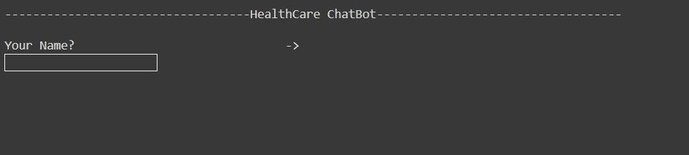
Output Screenshots:

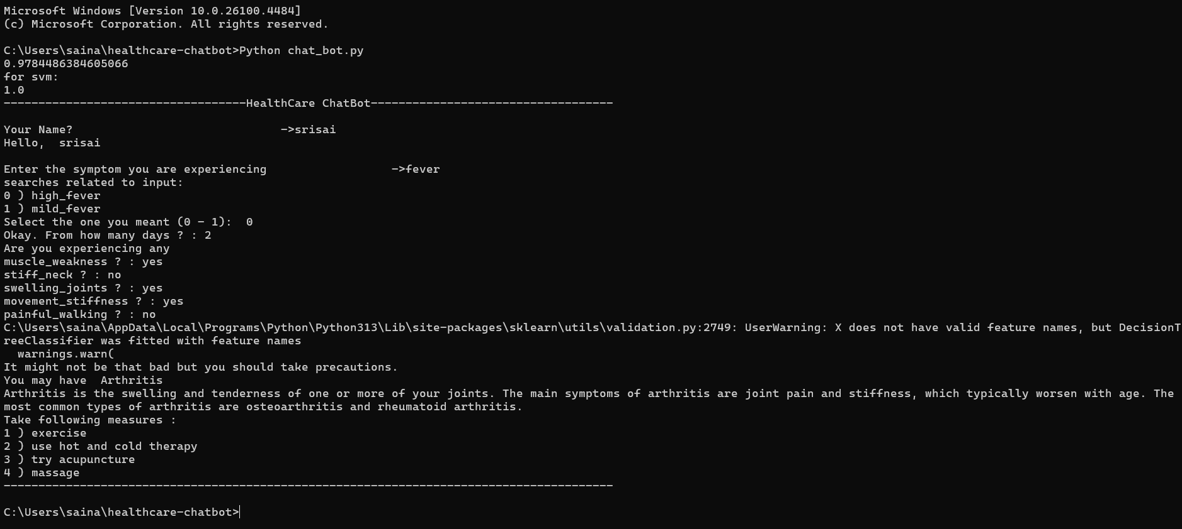

CHAPTER 9
CONCLUSION AND FUTURE SCOPE

Conclusion
HELPI is an innovative and user-friendly tool designed to assist individuals in assessing their symptoms, predicting potential diseases, and providing relevant measures to be taken. By simply inputting their symptoms into the chatbot, users can receive valuable insights and recommendations to better understand their health condition. The chatbot utilizes machine learning algorithms and a comprehensive medical database to analyze the symptoms provided by the user. It employs a decision tree model, to predict the most probable disease based on the symptoms reported. This predictive capability allows for early detection and intervention, leading to improved health outcomes.

Once the disease is predicted, the chatbot offers a range of precautionary measures and recommendations to be taken. These measures may include lifestyle modifications, suggested treatments, self-care practices, and preventive strategies. The chatbot provides accurate and upto-date information about the recommended measures, ensuring users have access to reliable healthcare advice.

The chatbot's user-friendly interface and conversational approach make it accessible to individuals of all technical backgrounds. It can be easily accessed, allowing users to seek medical guidance anytime, anywhere. With the ability to accurately predict diseases based on symptoms and provide relevant measures, our healthcare chatbot empowers individuals to make informed decisions about their health. It acts as a reliable virtual healthcare companion, offering personalized support and guidance throughout the user's healthcare journey.

In summary, our healthcare chatbot is a cutting-edge solution that combines machine learning techniques, medical expertise, and user-friendly interface to facilitate symptom assessment, disease prediction, and provision of necessary measures. It aims to improve healthcare accessibility, empower individuals, and promote proactive healthcare management.
Future Scope

HELPI can be developed to provide emotional support and assist in mental health services. They can offer resources, coping strategies, and referrals to mental health professionals, helping individuals manage stress, anxiety, and other mental health concerns.
Personalized Health Monitoring and Recommendations HELPI can be enhanced to provide personalized health monitoring by integrating with wearable devices and health apps. This would allow the chatbot to track vital signs, activity levels, and other health-related data, providing personalized recommendations for improving health and wellness.
Advanced Diagnostic Capabilities HELPI can be improved to have more advanced diagnostic capabilities by incorporating machine learning algorithms and leveraging large medical datasets. By leveraging this capability, the chatbot can enhance its predictive accuracy and offer informed suggestions for potential diagnoses, utilizing the user's symptoms and medical history as valuable inputs.
Integration with Electronic Health Records (EHR) HELPI can be enhanced to integrate with EHR systems to access and analyze patient data in real-time. This integration would enable chatbots to provide personalized recommendations, track patient progress, and assist healthcare providers in making informed decisions.
Natural Language Processing (NLP) Improvements Advancements in NLP can enhance the HELPI 's ability to understand and interpret user queries more accurately. This includes handling complex medical terminology, understanding context, and providing more relevant and precise responses.
Expanded Medical Knowledge Base HELPI can be continuously updated with the latest medical research, treatment guidelines, and clinical knowledge to ensure that they provide the most up-to-date and reliable information to users. Regular updates would help the chatbot stay current with medical advancements and provide accurate recommendations.
Multilingual Support Expanding the HELPI 's language capabilities to support multiple languages would make healthcare services more accessible to a diverse population. This could involve incorporating translation services or training the chatbot in different languages.
Improved User Experience and Interface Enhancements in the HELPI 's user interface and overall user experience can make interactions more intuitive and engaging. Incorporating visual elements, voice recognition, and natural language understanding can enhance the overall usability and satisfaction of users. Overall, the future of HELPI brings numerous benefits to users, healthcare systems and healthcare providers.

REFERENCES
- A Systematic Review of Chatbot Applications in Mental Healthcare - S. Smith in National Library of Medicine
- An Empirical Study on the Effectiveness of Chatbots in Patient Education - J. Brown
- Exploring the Acceptance and Usability of Chatbots in Elderly Care Settings - M.
Johnson,
- Chatbots for Chronic Disease Management: A Review of Current Applications and
Challenges - A. Martinez
- Improving Medication Adherence through Chatbot-based Reminders - L. Thompson
- Enhancing Patient Engagement through Intelligent Chatbots in Primary Care - R. Garcia
- Evaluating the Accuracy of Chatbot-based Symptom Assessment for Common Diseases – K. Wilson

